Tutorial 4

- Your software company has recently secured a project to develop an online banking system for a local bank. Assume that your team is at Requirements Validation phase now and your team has identified some inconsistency and conflicts problems on the requirements that gathered from the previous phase.

- With the aid of examples, differentiate the three common types of inconsistency in requirements, i.e. Terminology clash, Designation clash and Structure clash.
Terminology clash
- Same concept name differently in different statement
- Eg: participating, attending, meeting
Designation clash
- Same name for different concepts in different statement
- Eg: participant in a meeting - participating full meeting tail end or participating partial meeting
Structure Clash
- Same concept structure differently in different statement
- Eg: “Latest return date” - as time point Friday, 5pm or time interval Friday

- What are the activities that your team would perform in managing requirements conflict for the project?
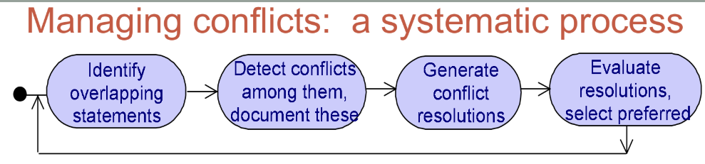
- The table below shows the risk likelihood, consequences and severity information for one of the identified risks for the above project. Calculate the risk exposure for each independent consequence. What is the overall risk exposure? You are required to show all your workings clearly. All the values should be rounded up to 3 decimal points.

Risk : “The online banking system fails to perform the intended operation”

 | Risk likelihood
Consequences | Likely (0.8) | Possible (0.5) | Unlikely (0.2)
Unsatisfactory customers | 10 | 8 | 6
Bad reputation | 8 | 8 | 4
Number of customers decreased | 6 | 6 | 2

Note: Assume that the scale of severity level are 10, 8, 6, 4 and 2 for catastrophic, severe, high, moderate and low respectively.

The risk exposure:
- Unsatisfied : [ (0.8*10) + (0.5*8) + (0.2*6) ] = 13.2
- Bad reputation : [ (0.8*8) + (0.5*8) + (0.2*4) ] = 11.2
- Number of customer decrease: [ (0.8*6) + (0.5*6) + (0.2*2) ] = 8.2
Therefore, the overall exposure risk is 32.6

- Explain any TWO (2) conflict resolution tactics. (Use examples for your explanation)
Eg: Library system
Scenario 1 : “A borrower should return book copy within 2 weeks.”
: “A borrower should keep the borrowed book copy as long as he/she needs it.”
Above 2 requirement statements are conflicting, so the conflict resolution tactics can be:-
- Avoid boundary condition – Ensure in some way that the boundary condition for a conflict will never be true.
- e.g. “Keep copies of highly needed books unborrowable”
Restore conflicting statements – Ensure in some way that the conflicting statements become together satisfiable again reasonably soon after the boundary condition has occurred.
- e.g. “Copy returned within X weeks and then borrowed again”
Weaken conflicting statements – Make one or several conflicting statements less restrictive so that the conflict no longer exists.
- e.g. “Copy returned within X weeks unless explicit permission”
Drop lower-priority statements

Scenario 2 : “ Allow users to be informed about loan status of books.”
: “Do not allow students to know which user has borrowed what.”
Above 2 requirement statements are conflicting, so the conflict resolution tactic can be:-
- Specialize conflict source or target – Identify the source/target objects involved in conflicting statements and specialize these so that conflicting disappear.
- e.g. “Book loan status known by staff users only”

- With aid of examples, differentiate product-related risk from process-related risk.

Product related risk
- Negative impact on FR or NFR objective of the system
- Eg1: failure to generate monthly sales report
- Eg2: security threats

Process
- Negative impact on development objectives
- Eg: personnel turnover, delay delivery or cost overrun

- Stages involved in Risk Management of requirements engineering

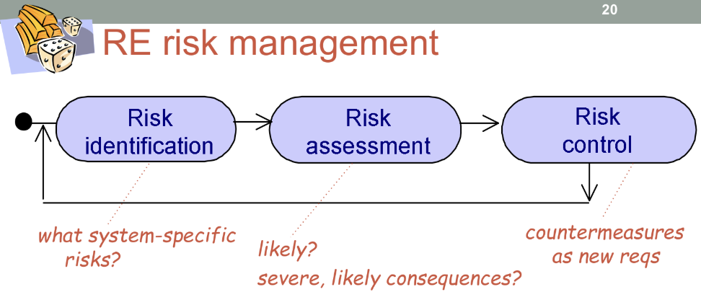

- Risk identification
- To identify the potential product-related or process-related risk in requirements
- Some common risk identification techniques are risk checklist, components inspection, risk tree and elicitation technique like scenario, knowledge reuse, or group session
- To access likelihood of risk and severity as well as likelihood of consequences
- To control high priorities risk
- Two types of risk assessment : qualitative assessment and quantitative assessment

- Risk Control
- To reduce high exposure risk to counter measure and to yield new or adapted requirements
- It should be called effective
- Two mains step in control: exposure counter, evaluating counter measures and select referred

Tutorial 4 (Cont’)

- You are given the following risk Impact matrix and Effectiveness matrix for a project, complete the matrices. Show your workings clearly. All the values should be rounded up to 3 decimal points.

Risk
Objectives | System failure  (likelihood: 0.3) | System provide inaccurate data  (likelihood: 0.5) | System attack by unauthorized personnel  (likelihood: 0.3) | Loss of objective
Improve customer services  (weight : 0.3) | 0.5 | 0.7 | 0.5 | 0.3 * [ (0.5*0.3) + (0.7*0.5) + (0.5*0.3)]  = 0.195
Clients P&C data will be protected (weight : 0.4) | 0.1 | 0 | 0.9 | 0.4 * [ (0.4*0.3) + (0.0*0.5) + (0.9*0.3)]  = 0.120
Improve staff job satisfaction (weight : 0.3) | 0.7 | 0.2 | 0.3 | 0.3 * [ (0.7*0.3) + (0.2*0.5) + (0.3*0.3)]  = 0.120
Risk Critically | 0.3 * [ (0.5*0.3) + (0.1*0.4) + (0.7*0.3) ]  = 0.120

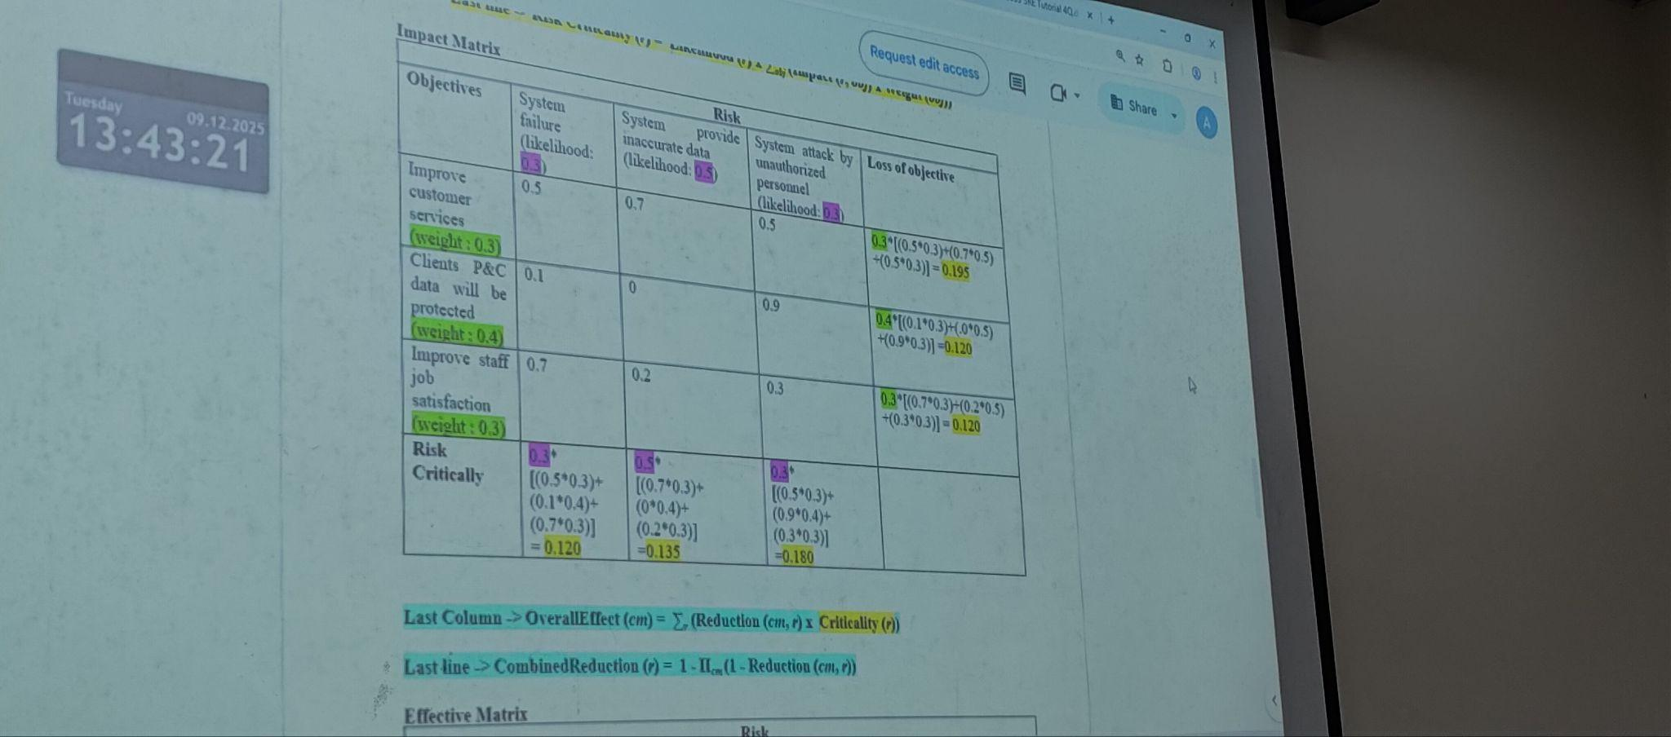
Effective Matrix

Risk
Countermeasures | System failure  (likelihood: 0.3) | System provide inaccurate data  (likelihood: 0.5) | System access by unauthorized personnel  (likelihood: 0.4) | Overall Effect of countermeasure
Install firewall | 0 | 0 | 0.9
Systematic & detailed system testing by QA team | 0.8 | 1 | 0
Software  re-engineering | 0.7 | 0.8 | 0.2
Combined risk reduction

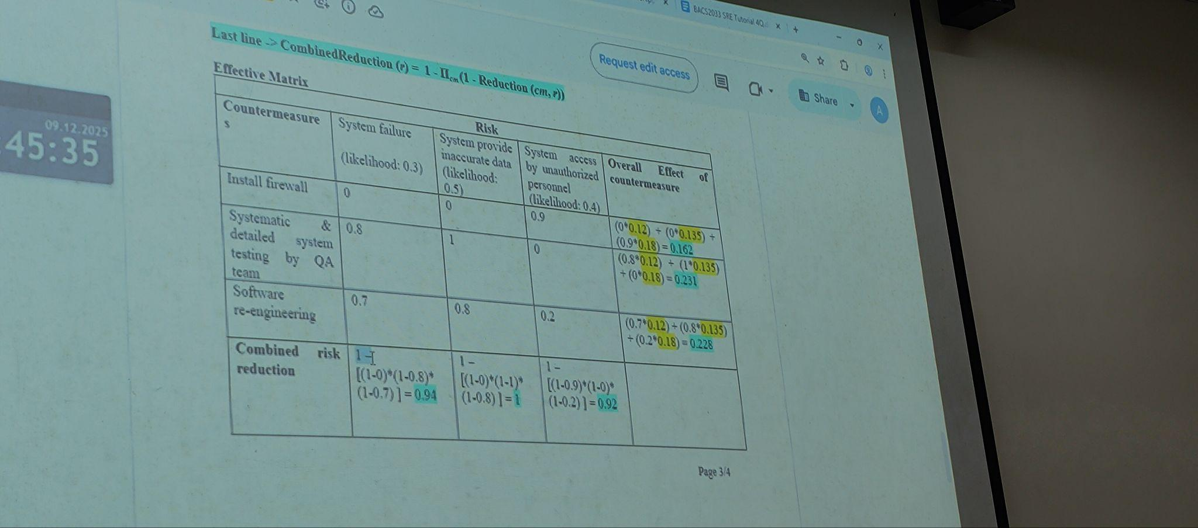
Tutorial 4 (Cont’)

- You, as a project manager, are in the midst of evaluating and prioritizing the software requirements for a project.

- Assume that the software options to be evaluated are: “Get customer feedbacks by email” or “Get customer feedbacks by e-form”. The evaluation criteria are Fast Response, Response Rate and Reliable Response. The significance weighting for the above three criteria are 0.20, 0.30 and 0.50 respectively.

The estimating option scores for “Get customer feedbacks by email” on the three criteria are 0.60, 0.30 and 0.40 respectively. On the other hand, the estimating option scores for “Get customer feedbacks by e-form” on the three criteria are 0.80, 0.70 and 0.40 respectively.

- Prepare a weighted matrix for estimating the total score of each option on each evaluation criterion. You are required to show all your workings clearly. All the values should be rounded up to 3 decimal points. (9M)

- Which is the best software option? (1M)

- Evaluate the importance of requirements prioritization.

